**MẪU THIẾT KẾ - CTK 44**

**LAB 4: TÌM HIỂU VÀ CÀI ĐẶT NHÓM MẪU BEHAVIORAL**

### 1. Chain of Responsibility

**Ví dụ 1:**

* Handler: abstract class/ interface with method handleRequest()
* ConcreteHandler1, ConcreteHandler2: subclasses implement handleRequest()
* Client: sends request to the first handler

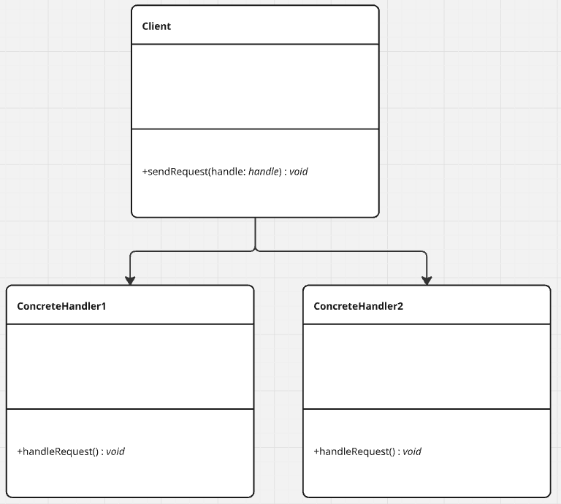

**Ví dụ 2:**

* Logger (abstract): handles log levels
* ErrorLogger, FileLogger, ConsoleLogger: concrete loggers in chain
* MainApp: passes log messages to first logger

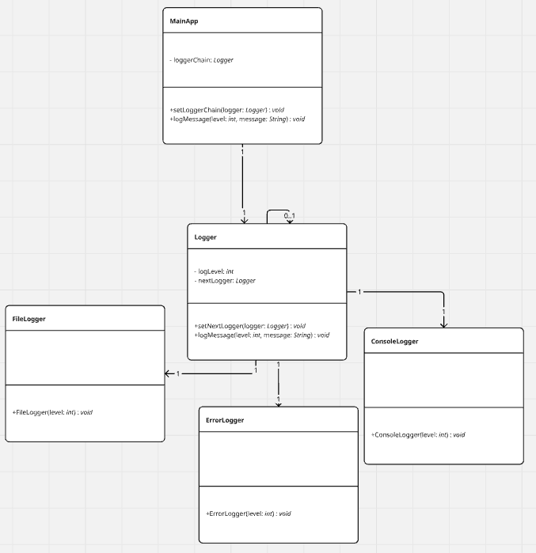

### 2. Command

**Ví dụ 1:**

* Command (interface): declares execute()
* ConcreteCommand: implements Command and calls Receiver
* Receiver: knows how to perform actions
* Invoker: stores command and triggers execution

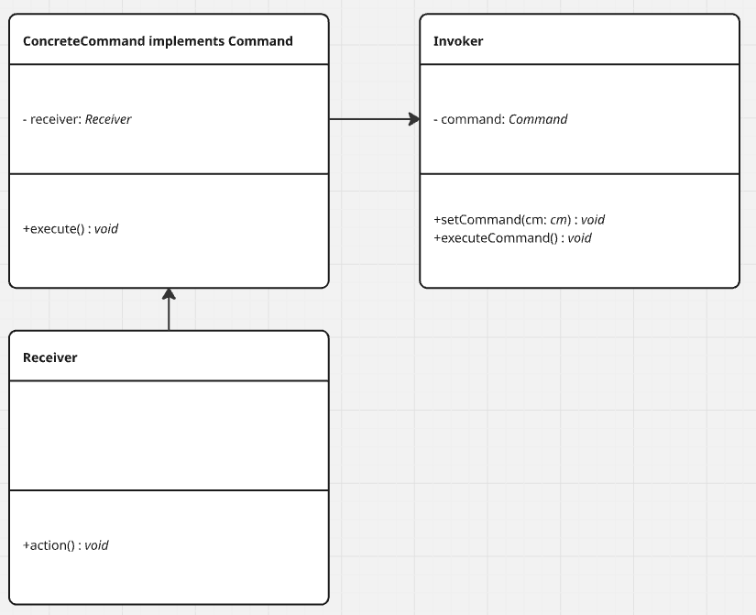

**Ví dụ 2:**

* Light (Receiver)
* LightOnCommand, LightOffCommand (ConcreteCommand)
* RemoteControl (Invoker)

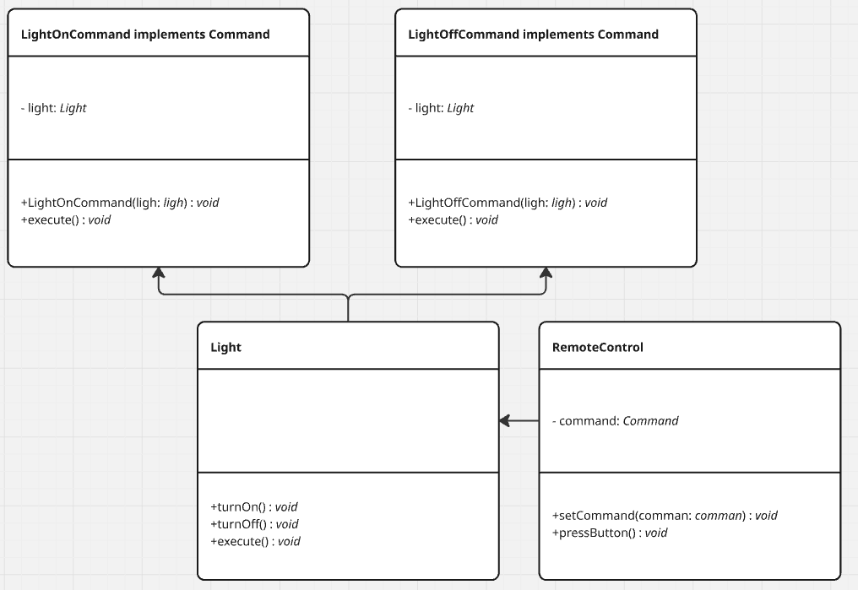

### 3. Interpreter

**Ví dụ 1:**

* AbstractExpression: interpret()
* TerminalExpression, NonTerminalExpression
* Context: contains input/output for interpreter

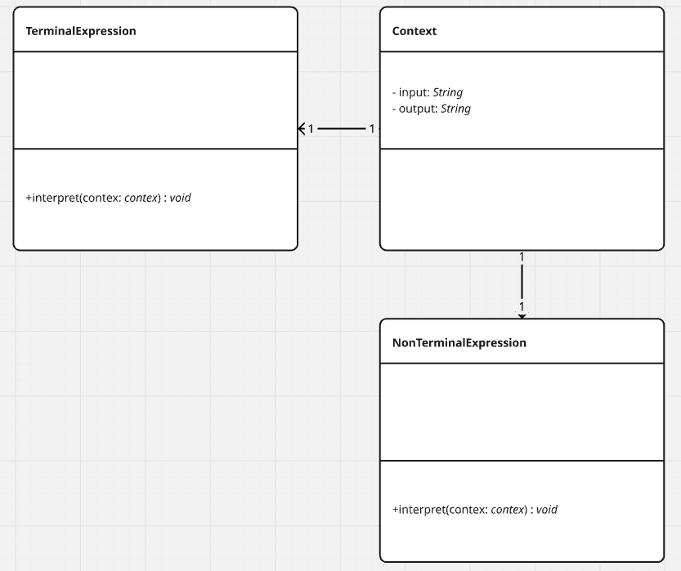

**Ví dụ 2:**

* RomanNumeralExpression (Terminal)
* PlusExpression, MinusExpression (NonTerminal)
* Context: string of Roman numerals

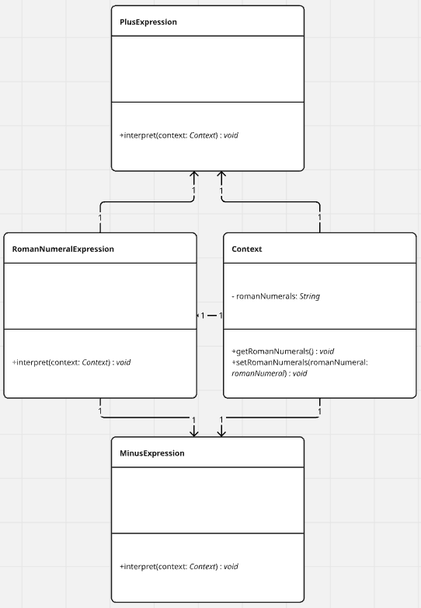

### 4. Iterator

**Ví dụ 1:**

* Iterator: interface with hasNext(), next()
* ConcreteIterator: implements Iterator
* Aggregate: interface with createIterator()
* ConcreteAggregate: implements Aggregate

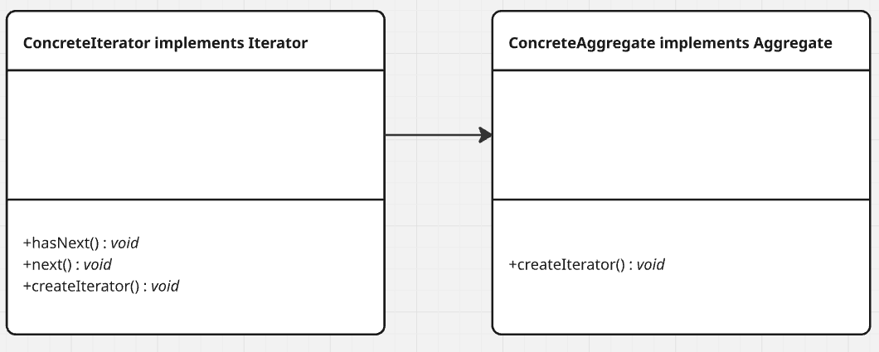

**Ví dụ 2:**

* BookCollection (ConcreteAggregate)
* BookIterator (ConcreteIterator)
* Book (Item)
* Client: iterates through books

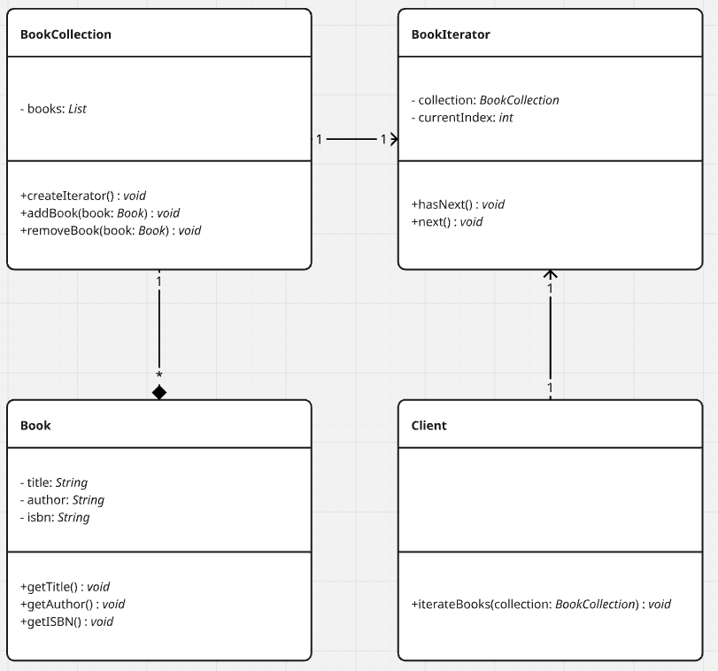

### 5. Mediator

**Ví dụ 1:**

* Mediator (interface)
* ConcreteMediator: coordinates colleagues
* Colleague (abstract)
* ConcreteColleague1, ConcreteColleague2

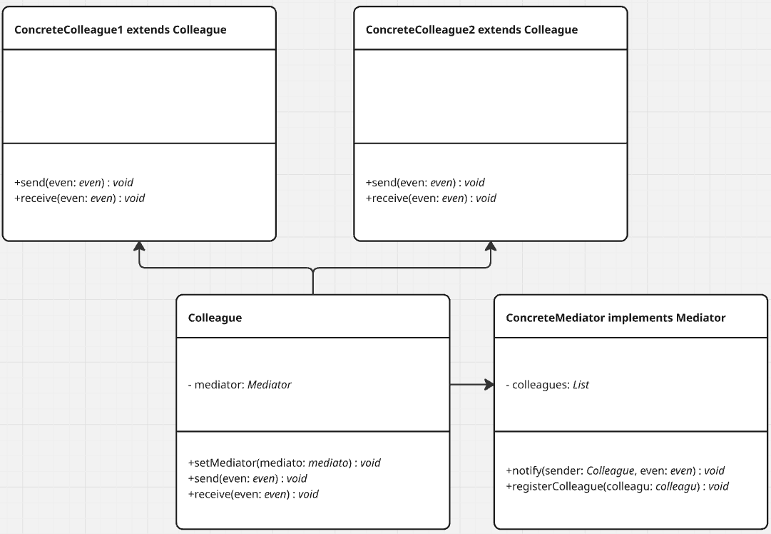

**Ví dụ 2:**

* ChatRoom (Mediator)
* User (Colleague)
* ConcreteChatRoom: sends/receives messages between users

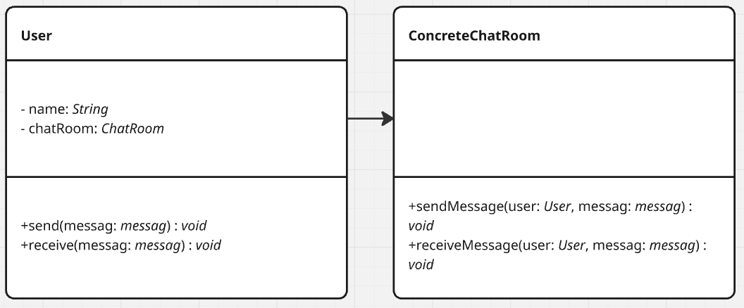

### 6. Memento

**Ví dụ 1:**

* Originator: creates memento, restores state
* Memento: stores state
* Caretaker: keeps memento

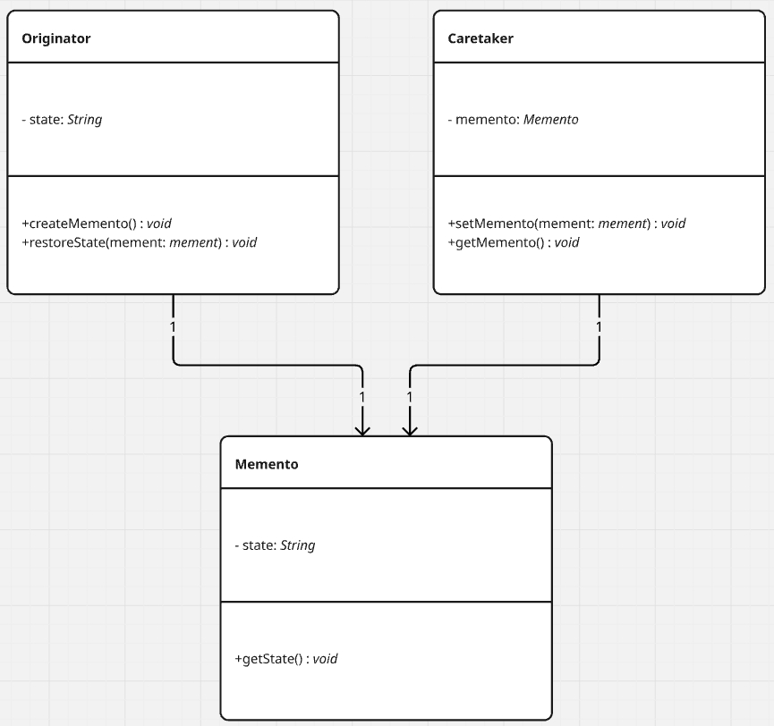

**Ví dụ 2:**

* TextEditor (Originator)
* TextState (Memento)
* HistoryManager (Caretaker)

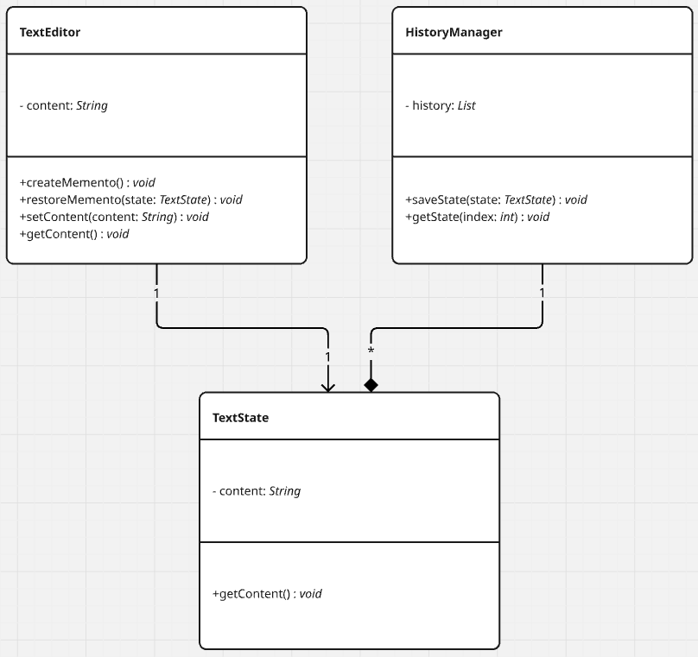

### 7. Observer

**Ví dụ 1:**

* Subject: attach(), detach(), notify()
* ConcreteSubject: maintains observers
* Observer (interface)
* ConcreteObserver: updates when notified

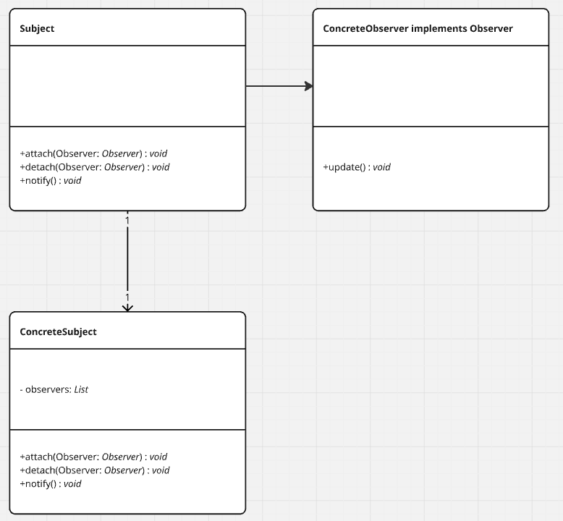

**Ví dụ 2:**

* WeatherStation (Subject)
* DisplayDevice (Observer)
* TemperatureDisplay, HumidityDisplay (ConcreteObserver)

